# CS 255 System Design Document Template

This template lays out all the different sections that you need to complete for Project Two. Each section has guidance to prompt your thinking. You will need to continually reference the interview transcript as you work to make sure that you are addressing your client’s needs. There is no required length for the final document. Instead the goal is to complete each section based on what your client’s needs are. Remove this note when you are finished, and replace all bracketed text with the relevant information.

## UML Diagrams

### UML Use Case Diagram

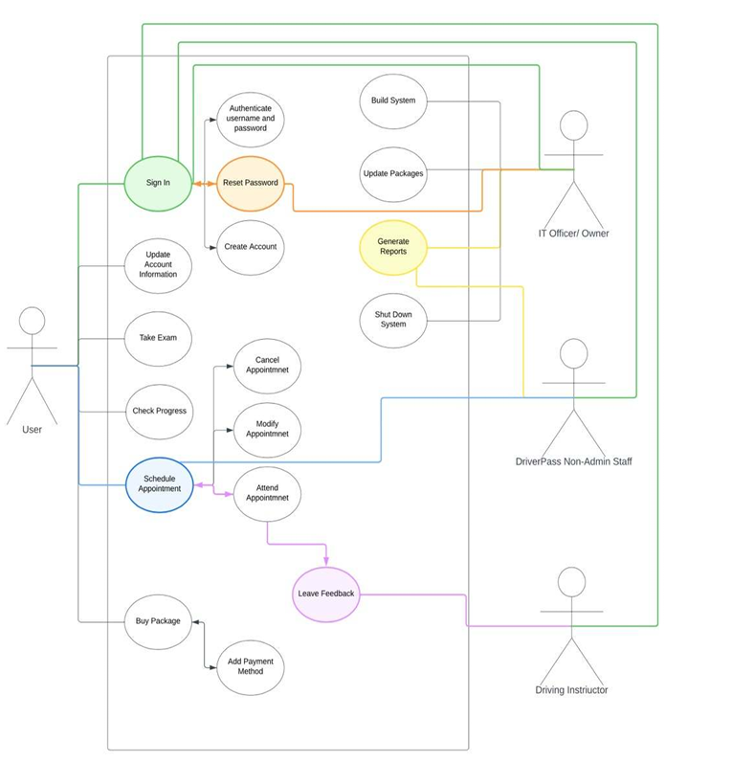

### UML Activity Diagrams

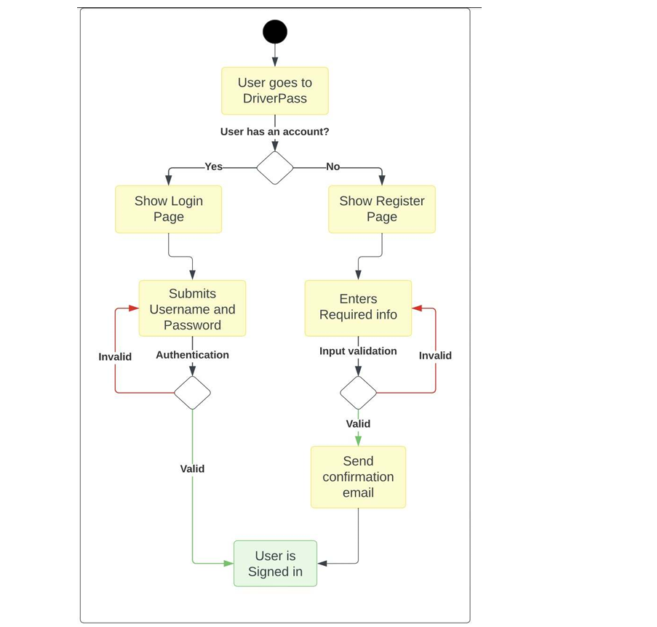

### UML Sequence Diagram

### UML Class Diagram

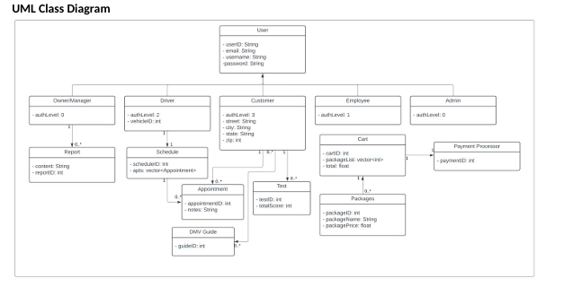

## Technical Requirements

* **Hardware Requirements**

- Dedicated Server

- Reliable Internet connection

- Adequate storage for database and website data

- Computer or mobile device for user access to the website

- Implementation of a firewall to safeguard website ports

* **Software Requirements**

**-** Utilization of Windows Server (recommended) for its stability

- Deployment of SQL Server (recommended) for the database (most stable release)

- Integration of backup software for both websites and database

- Implementation of a web server such as Apache

- Inclusion of security software to prevent malware threats

**Geographic Considerations:**

**-** Ensuring website accessibility in America

**-** Securing the website and database server in a data center

**-** Placing the server in a central location for optimized performance and accessibility